Home Page

Definition
# Source: AI Source: Provided by: [Data Path: Persons Table -> ID Column: 1, Name_En Column: Motasem Essam] -> From: [Chatgpt (GPT‑5 Mini)] on [2/12/2026]
A Home Page is the main or first page of a website that visitors see when they type a website’s address (URL) into a browser.

Simple Definition
# Source: AI Source: Provided by: [Data Path: Persons Table -> ID Column: 1, Name_En Column: Motasem Essam] -> From: [Chatgpt (GPT‑5 Mini)] on [2/12/2026]
Home Page = the “front door” of a website, giving an overview and guiding users to other pages.

Key Features of a Home Page
# Source: AI Source: Provided by: [Data Path: Persons Table -> ID Column: 1, Name_En Column: Motasem Essam] -> From: [Chatgpt (GPT‑5 Mini)] on [2/12/2026]
- Introduction / Overview – shows what the website or business is about
- Navigation Menu – links to other pages like About, Services, Blog, Contact
- Featured Content – highlights important products, services, or articles
- Call-to-Action (CTA) – encourages users to take action (sign up, buy, contact)
- Visual Elements – images, banners, videos, sliders

Purpose of a Home Page
# Source: AI Source: Provided by: [Data Path: Persons Table -> ID Column: 1, Name_En Column: Motasem Essam] -> From: [Chatgpt (GPT‑5 Mini)] on [2/12/2026]
- Make a good first impression
- Help visitors find information quickly
- Guide users to important sections of the website
- Represent the brand or person professionally

Examples of Home Pages
# Source: AI Source: Provided by: [Data Path: Persons Table -> ID Column: 1, Name_En Column: Motasem Essam] -> From: [Chatgpt (GPT‑5 Mini)] on [2/12/2026]
- google.com → search engine interface
- amazon.com → featured products and categories
- apple.com → overview of products, highlights, and links

Difference Between Home Page and Web Page
# Source: AI Source: Provided by: [Data Path: Persons Table -> ID Column: 1, Name_En Column: Motasem Essam] -> From: [Chatgpt (GPT‑5 Mini)] on [2/12/2026]
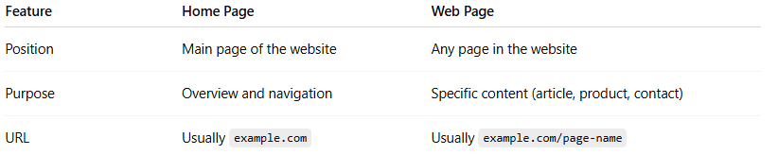
Feature | Home Page | Web Page
Position | Main page of the website | Any page in the website
Purpose | Overview and navigation | Specific content (article, product, contact)
URL | Usually example.com | Usually example.com/page-name

